UNIT II ETHERNET

Physical Layer: Introduction-Purpose of the physical layer – Physical layer Characteristics-Copper Cabling-UTP Cabling-Fiber Optic Cabling-Wireless Media
Number Systems: Introduction –Binary Number Systems-Hexadecimal Number System
Datalink Layer: Introduction- Purpose of the Data link layer-Topologies-Data Link Frame
Ethernet switching: Introduction – Ethernet Frames-Ethernet MAC Address-The Mac Address table-Switch speeds and Forwarding Methods.

2.1 Physical Layer

- The physical layer is responsible for carrying individual bits in a frame across the link.
- The physical layer is the lowest level in the TCP/IP protocol suite.
- The communication between two devices at the physical layer is still a logical communication because there is another hidden layer, the transmission media, under the physical layer

2.1.1 Introduction

This layer includes the physical equipment involved in the data transfer, such as the cables and switches. This is also the layer where the data gets converted into a bit stream, which is a string of 1s and 0s. The physical layer of both devices must also agree on a signal convention so that the 1s can be distinguished from the 0s on both devices.

2.1.2 Purpose of Physical Layer

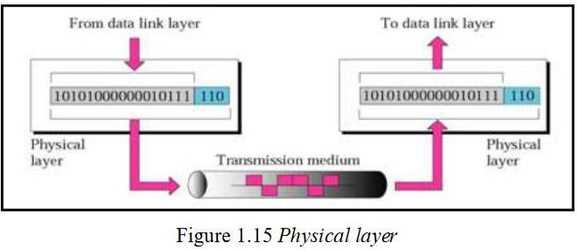

2.1.3 Physical Layer Characteristics
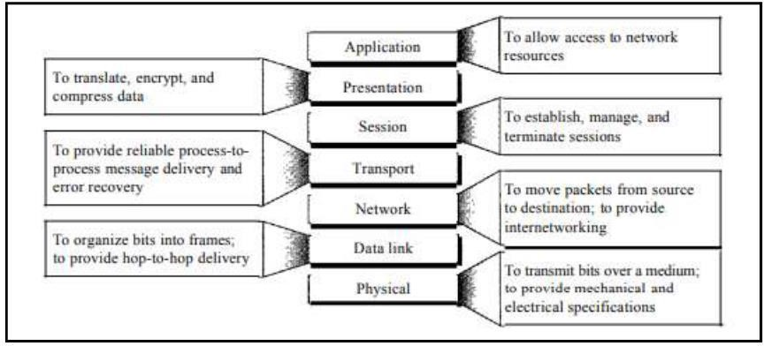

2.1.4 Copper Cabling

Characteristics of Copper Cabling
Copper cabling is the most common type of cabling used in networks today. In fact, copper cabling is not just one type of cable. There are three different types of copper cabling that are each used in specific situations.
Networks use copper media because it is inexpensive, easy to install, and has low resistance to electrical current. However, copper media is limited by distance and signal interference.
Data is transmitted on copper cables as electrical pulses. A detector in the network interface of a destination device must receive a signal that can be successfully decoded to match the signal sent. However, the farther the signal travels, the more it deteriorates. This is referred to as signal attenuation. For this reason, all copper media must follow strict distance limitations as specified by the guiding standards.
The timing and voltage values of the electrical pulses are also susceptible to interference from two sources:
- Electromagnetic interference (EMI) or radio frequency interference (RFI) - EMI and RFI signals can distort and corrupt the data signals being carried by copper media. Potential sources of EMI and RFI include radio waves and electromagnetic devices, such as fluorescent lights or electric motors.
- Crosstalk - Crosstalk is a disturbance caused by the electric or magnetic fields of a signal on one wire to the signal in an adjacent wire. In telephone circuits, crosstalk can result in hearing part of another voice conversation from an adjacent circuit. Specifically, when an electrical current flows through a wire, it creates a small, circular magnetic field around the wire, which can be picked up by an adjacent wire.
To counter the negative effects of EMI and RFI, some types of copper cables are wrapped in metallic shielding and require proper grounding connections.
To counter the negative effects of crosstalk, some types of copper cables have opposing circuit wire pairs twisted together, which effectively cancels the crosstalk.
The susceptibility of copper cables to electronic noise can also be limited using these recommendations:
- Selecting the cable type or category most suited to a given networking environment
- Designing a cable infrastructure to avoid known and potential sources of interference in the building structure
- Using cabling techniques that include the proper handling and termination of the cables
- Unshielded twisted-pair (UTP) cabling is the most common networking media. UTP cabling, terminated with RJ-45 connectors, is used for interconnecting network hosts with intermediary networking devices, such as switches and routers.
- In LANs, UTP cable consists of four pairs of color-coded wires that have been twisted together and then encased in a flexible plastic sheath that protects from minor physical damage. The twisting of wires helps protect against signal interference from other wires.
- As seen in the figure, the color codes identify the individual pairs and wires and aid in cable termination.
- UTP cable showing the outer cable jacket (labeled 1), the twisted wire pairs (labeled 2), and the orange, green, blue, and brown insulation (labeled 3)
- 123

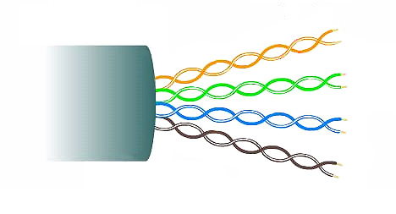
Shielded twisted-pair (STP)
Shielded twisted-pair (STP) provides better noise protection than UTP cabling. However, compared to UTP cable, STP cable is significantly more expensive and difficult to install. Like UTP cable, STP uses an RJ-45 connector.
STP cables combine the techniques of shielding to counter EMI and RFI, and wire twisting to counter crosstalk. To gain the full benefit of the shielding, STP cables are terminated with special shielded STP data connectors. If the cable is improperly grounded, the shield may act as an antenna and pick up unwanted signals.
The STP cable shown uses four pairs of wires, each wrapped in a foil shield, which are then wrapped in an overall metallic braid or foil.
STP cable showing the outer cable jacket (labeled 1), a braided shield around all the wire pairs (labeled 2), foil shields around the individual wire pairs (labeled 3), and the twisted colored wire pairs (labeled 4)
1234
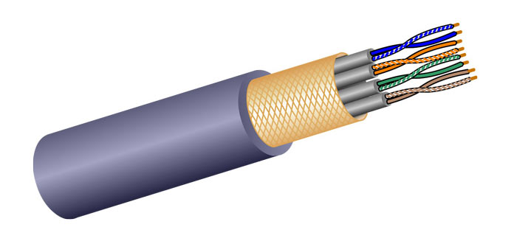

Coaxial cable
Coaxial cable, or coax for short, gets its name from the fact that there are two conductors that share the same axis. As shown in the figure, coaxial cable consists of the following:
- A copper conductor is used to transmit the electronic signals.
- A layer of flexible plastic insulation surrounds a copper conductor.
- The insulating material is surrounded in a woven copper braid, or metallic foil, that acts as the second wire in the circuit and as a shield for the inner conductor. This second layer, or shield, also reduces the amount of outside electromagnetic interference.
- The entire cable is covered with a cable jacket to prevent minor physical damage.
There are different types of connectors used with coax cable. The Bayonet Neill-Concelman (BNC), N type, and F type connectors are shown in the figure.
Although UTP cable has essentially replaced coaxial cable in modern Ethernet installations, the coaxial cable design is used in the following situations:
- Wireless installations - Coaxial cables attach antennas to wireless devices. The coaxial cable carries radio frequency (RF) energy between the antennas and the radio equipment.
- Cable internet installations - Cable service providers provide internet connectivity to their customers by replacing portions of the coaxial cable and supporting amplification elements with fiber-optic cable. However, the wiring inside the customer's premises is still coax cable.
three figures showing the construction of a coaxial cable, a cross-section of a coaxial cable, and three types of coaxial cable connectors.
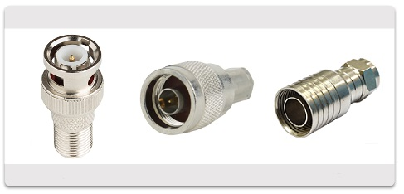

2.1.5 UTP Cabling

Properties of UTP Cabling
In the previous topic, you learned a bit about unshielded twisted-pair (UTP) copper cabling. Because UTP cabling is the standard for use in LANs, this topic goes into detail about its advantages and limitations, and what can be done to avoid problems.
When used as a networking medium, UTP cabling consists of four pairs of color-coded copper wires that have been twisted together and then encased in a flexible plastic sheath. Its small size can be advantageous during installation.
UTP cable does not use shielding to counter the effects of EMI and RFI. Instead, cable designers have discovered other ways that they can limit the negative effect of crosstalk:
- Cancellation - Designers now pair wires in a circuit. When two wires in an electrical circuit are placed close together, their magnetic fields are the exact opposite of each other. Therefore, the two magnetic fields cancel each other and also cancel out any outside EMI and RFI signals.
- Varying the number of twists per wire pair - To further enhance the cancellation effect of paired circuit wires, designers vary the number of twists of each wire pair in a cable. UTP cable must follow precise specifications governing how many twists or braids are permitted per meter (3.28 feet) of cable. Notice in the figure that the orange/orange white pair is twisted less than the blue/blue white pair. Each colored pair is twisted a different number of times.
UTP cable relies solely on the cancellation effect produced by the twisted wire pairs to limit signal degradation and effectively provide self-shielding for wire pairs within the network media.
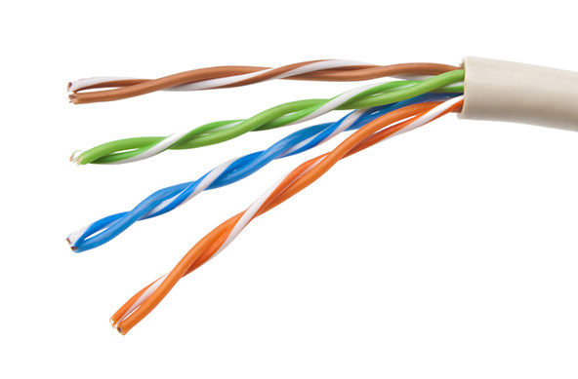

UTP Cabling Standards and Connectors
UTP cabling conforms to the standards established jointly by the TIA/EIA. Specifically, TIA/EIA-568 stipulates the commercial cabling standards for LAN installations and is the standard most commonly used in LAN cabling environments. Some of the elements defined are as follows:
- Cable types
- Cable lengths
- Connectors
- Cable termination
- Methods of testing cable
The electrical characteristics of copper cabling are defined by the Institute of Electrical and Electronics Engineers (IEEE). IEEE rates UTP cabling according to its performance. Cables are placed into categories based on their ability to carry higher bandwidth rates. For example, Category 5 cable is used commonly in 100BASE-TX Fast Ethernet installations. Other categories include Enhanced Category 5 cable, Category 6, and Category 6a.
Cables in higher categories are designed and constructed to support higher data rates. As new gigabit speed Ethernet technologies are being developed and adopted, Category 5e is now the minimally acceptable cable type, with Category 6 being the recommended type for new building installations.
Straight-through and Crossover UTP Cables
Different situations may require UTP cables to be wired according to different wiring conventions. This means that the individual wires in the cable have to be connected in different orders to different sets of pins in the RJ-45 connectors.
The following are the main cable types that are obtained by using specific wiring conventions:
- Ethernet Straight-through - The most common type of networking cable. It is commonly used to interconnect a host to a switch and a switch to a router.
- Ethernet Crossover - A cable used to interconnect similar devices. For example, to connect a switch to a switch, a host to a host, or a router to a router. However, crossover cables are now considered legacy as NICs use medium-dependent interface crossover (auto-MDIX) to automatically detect the cable type and make the internal connection.
Note: Another type of cable is a rollover cable, which is Cisco proprietary. It is used to connect a workstation to a router or switch console port.
Using a crossover or straight-through cable incorrectly between devices may not damage the devices, but connectivity and communication between the devices will not take place. This is a common error and checking that the device connections are correct should be the first troubleshooting action if connectivity is not achieved.
2.1.6 Fiber-Optic Cabling

Properties of Fiber-Optic Cabling
As you have learned, fiber-optic cabling is the other type of cabling used in networks. Because it is expensive, it is not as commonly used at the various types of copper cabling. But fiber-optic cabling has certain properties that make it the best option in certain situations, which you will discover in this topic.
Optical fiber cable transmits data over longer distances and at higher bandwidths than any other networking media. Unlike copper wires, fiber-optic cable can transmit signals with less attenuation and is completely immune to EMI and RFI. Optical fiber is commonly used to interconnect network devices.
Optical fiber is a flexible, but extremely thin, transparent strand of very pure glass, not much bigger than a human hair. Bits are encoded on the fiber as light impulses. The fiber-optic cable acts as a waveguide, or “light pipe,” to transmit light between the two ends with minimal loss of signal.
As an analogy, consider an empty paper towel roll with the inside coated like a mirror. It is a thousand meters in length, and a small laser pointer is used to send Morse code signals at the speed of light. Essentially that is how a fiber-optic cable operates, except that it is smaller in diameter and uses sophisticated light technologies.
Types of Fiber Media
Fiber-optic cables are broadly classified into two types:
- Single-mode fiber (SMF)
- Multimode fiber (MMF)
Click each button for an illustration and explanation of each type.
Single-Mode Fiber
Multimode Fiber
Single-Mode Fiber
SMF consists of a very small core and uses expensive laser technology to send a single ray of light, as shown in the figure. SMF is popular in long-distance situations spanning hundreds of kilometers, such as those required in long haul telephony and cable TV applications.
A cross-section of a single-mode fiber optic cable consisting of a center glass core of 9 microns in diameter, surrounded by a glass cladding of 125 microns in diameter, surrounded by a polymeric coating. An x-ray vision sideview shows that this type of cable construction produces a single straight path for the light.
Glass Core diameter = 9 micrometer (µm)
Glass Cladding 125 microns diameter
Polymeric Coating
Produces single straight path for light

One of the highlighted differences between MMF and SMF is the amount of dispersion. Dispersion refers to the spreading out of a light pulse over time. Increased dispersion means increased loss of signal strength. MMF has a greater dispersion than SMF. That is why MMF can only travel up to 500 meters before signal loss.

Fiber-Optic Cabling Usage
Fiber-optic cabling is now being used in four types of industry:
- Enterprise Networks - Used for backbone cabling applications and interconnecting infrastructure devices
- Fiber-to-the-Home (FTTH) - Used to provide always-on broadband services to homes and small businesses
- Long-Haul Networks - Used by service providers to connect countries and cities
- Submarine Cable Networks - Used to provide reliable high-speed, high-capacity solutions capable of surviving in harsh undersea environments at up to transoceanic distances. Search the internet for “submarine cables telegeography map” to view various maps online.
Our focus in this course is the use of fiber within the enterprise.

Fiber-Optic Connectors
An optical-fiber connector terminates the end of an optical fiber. A variety of optical-fiber connectors are available. The main differences among the types of connectors are dimensions and methods of coupling. Businesses decide on the types of connectors that will be used, based on their equipment.
Note: Some switches and routers have ports that support fiber-optic connectors through a small form-factor pluggable (SFP) transceiver. Search the internet for various types of SFPs.
Click each fiber-optic connector type for an image and more information.
Straight-Tip (ST) Connectors
Subscriber Connector (SC) Connectors
Lucent Connector (LC) Simplex Connectors
Duplex Multimode LC Connectors
ST connectors were one of the first connector types used. The connector locks securely with a 'twist-on/twist-off' bayonet-style mechanism.
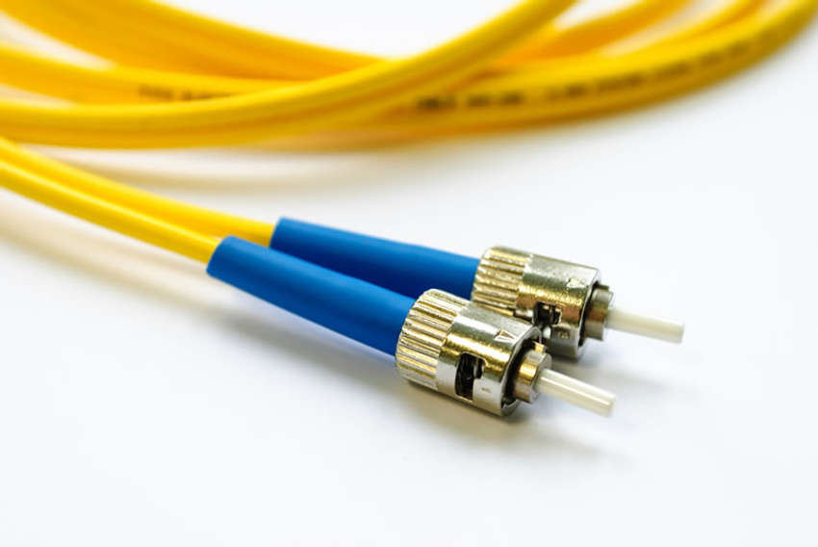

Until recently, light could only travel in one direction over optical fiber. Two fibers were required to support the full duplex operation. Therefore, fiber-optic patch cables bundle together two optical fiber cables and terminate them with a pair of standard, single-fiber connectors. Some fiber connectors accept both the transmitting and receiving fibers in a single connector known as a duplex connector, as shown in the Duplex Multimode LC Connector in the figure. BX standards such as 100BASE-BX use different wavelengths for sending and receiving over a single fiber.

Fiber Patch Cords
Fiber patch cords are required for interconnecting infrastructure devices. The use of color distinguishes between single-mode and multimode patch cords. A yellow jacket is for single-mode fiber cables and orange (or aqua) for multimode fiber cables.
Click each fiber patch cord for an image.
SC-SC Multimode Patch Cord
LC-LC Single-Mode Patch Cord
ST-LC Multimode Patch Cord
SC-ST Single-Mode Patch Cord
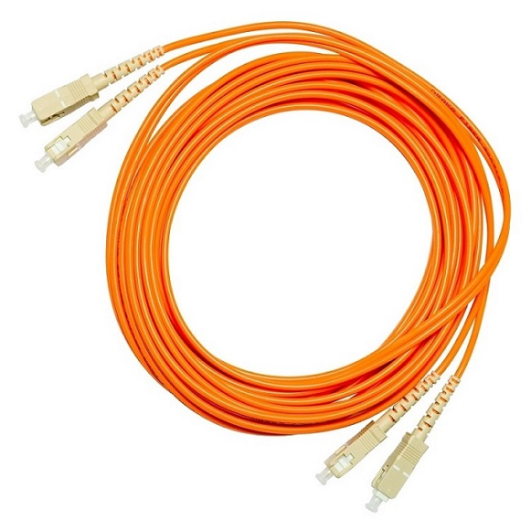

Note: Fiber cables should be protected with a small plastic cap when not in use.

2.1.7 Wireless Media
Properties of Wireless Media
You may be taking this course using a tablet or a smart phone. This is only possible due to wireless media, which is the third way to connect to the physical layer of a network.
Wireless media carry electromagnetic signals that represent the binary digits of data communications using radio or microwave frequencies.
Wireless media provide the greatest mobility options of all media, and the number of wireless-enabled devices continues to increase. Wireless is now the primary way users connect to home and enterprise networks.
These are some of the limitations of wireless:
- Coverage area - Wireless data communication technologies work well in open environments. However, certain construction materials used in buildings and structures, and the local terrain, will limit the effective coverage.
- Interference - Wireless is susceptible to interference and can be disrupted by such common devices as household cordless phones, some types of fluorescent lights, microwave ovens, and other wireless communications.
- Security - Wireless communication coverage requires no access to a physical strand of media. Therefore, devices and users, not authorized for access to the network, can gain access to the transmission. Network security is a major component of wireless network administration.
- Shared medium - WLANs operate in half-duplex, which means only one device can send or receive at a time. The wireless medium is shared amongst all wireless users. Many users accessing the WLAN simultaneously results in reduced bandwidth for each user.
Although wireless is increasing in popularity for desktop connectivity, copper and fiber are the most popular physical layer media for deployment of intermediary network devices, such as routers and switches.

Types of Wireless Media
The IEEE and telecommunications industry standards for wireless data communications cover both the data link and physical layers. In each of these standards, physical layer specifications are applied to areas that include the following:
- Data to radio signal encoding
- Frequency and power of transmission
- Signal reception and decoding requirements
- Antenna design and construction
These are the wireless standards:
- Wi-Fi (IEEE 802.11) - Wireless LAN (WLAN) technology, commonly referred to as Wi-Fi. WLAN uses a contention-based protocol known as carrier sense multiple access/collision avoidance (CSMA/CA). The wireless NIC must first listen before transmitting to determine if the radio channel is clear. If another wireless device is transmitting, then the NIC must wait until the channel is clear. Wi-Fi is a trademark of the Wi-Fi Alliance. Wi-Fi is used with certified WLAN devices based on the IEEE 802.11 standards.
- Bluetooth (IEEE 802.15) - This is a wireless personal area network (WPAN) standard, commonly known as “Bluetooth.” It uses a device pairing process to communicate over distances from 1 to 100 meters.
- WiMAX (IEEE 802:16) - Commonly known as Worldwide Interoperability for Microware Access (WiMAX), this wireless standard uses a point-to-multipoint topology to provide wireless broadband access.
- Zigbee (IEEE 802.15.4) - Zigbee is a specification used for low-data rate, low-power communications. It is intended for applications that require short-range, low data-rates and long battery life. Zigbee is typically used for industrial and Internet of Things (IoT) environments such as wireless light switches and medical device data collection.
Note: Other wireless technologies such as cellular and satellite communications can also provide data network connectivity. However, these wireless technologies are out of scope for this module.
Wireless LAN
A common wireless data implementation is enabling devices to connect wirelessly via a LAN. In general, a WLAN requires the following network devices:
- Wireless Access Point (AP) - These concentrate the wireless signals from users and connect to the existing copper-based network infrastructure, such as Ethernet. Home and small business wireless routers integrate the functions of a router, switch, and access point into one device, as shown in the figure.
- Wireless NIC adapters - These provide wireless communication capability to network hosts.
As the technology has developed, a number of WLAN Ethernet-based standards have emerged. When purchasing wireless devices, ensure compatibility and interoperability.
The benefits of wireless data communications technologies are evident, especially the savings on costly premises wiring and the convenience of host mobility. Network administrators must develop and apply stringent security policies and processes to protect WLANs from unauthorized access and damage.

Cisco Meraki MX64W
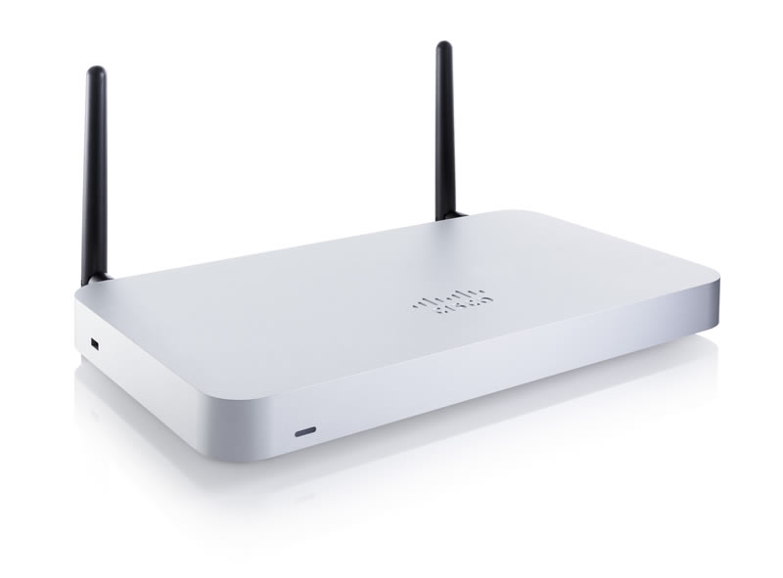

2.2 Number Systems

2.2.1 Introduction

IPv4 addresses begin as binary, a series of only 1s and 0s. These are difficult to manage, so network administrators must convert them to decimal. This topic shows you a few ways to do this.
Binary is a numbering system that consists of the digits 0 and 1 called bits. In contrast, the decimal numbering system consists of 10 digits consisting of the digits 0 - 9.
2.2.2 Binary Number Systems

Binary is important for us to understand because hosts, servers, and network devices use binary addressing. Specifically, they use binary IPv4 addresses, as shown in the figure, to identify each other.

2.2.3 Hexadecimal Number Systems
Learning to convert binary to decimal requires an understanding of positional notation. Positional notation means that a digit represents different values depending on the “position” the digit occupies in the sequence of numbers. You already know the most common numbering system, the decimal (base 10) notation system.
The decimal positional notation system operates as described in the table.
Radix | 10 | 10 | 10 | 10
Position in Number | 3 | 2 | 1 | 0
Calculate | (10³) | (10²) | (10¹) | (10⁰)
Position value | 1000 | 100 | 10 | 1
The following bullets describe each row of the table.
- Row 1, Radix is the number base. Decimal notation is based on 10, therefore the radix is 10.
- Row 2, Position in number considers the position of the decimal number starting with, from right to left, 0 (1st position), 1 (2nd position), 2 (3rd position), 3 (4th position). These numbers also represent the exponential value use to calculate the positional value in the 4th row.
- Row 3 calculates the positional value by taking the radix and raising it by the exponential value of its position in row 2.
Note: n⁰ is = 1.
- Row 4 positional value represents units of thousands, hundreds, tens, and ones.
To use the positional system, match a given number to its positional value. The example in the table illustrates how positional notation is used with the decimal number 1234.
 | Thousands | Hundreds | Tens | Ones
Positional Value | 1000 | 100 | 10 | 1
Decimal Number (1234) | 1 | 2 | 3 | 4
Calculate | 1 x 1000 | 2 x 100 | 3 x 10 | 4 x 1
Add them up… | 1000 | + 200 | + 30 | + 4
Result | 1,234
In contrast, the binary positional notation operates as described in the table.
Radix | 2 | 2 | 2 | 2 | 2 | 2 | 2 | 2
Position in Number | 7 | 6 | 5 | 4 | 3 | 2 | 1 | 0
Calculate | (2⁷) | (2⁶) | (2⁵) | (2⁴) | (2³) | (2²) | (2¹) | (2⁰)
Position value | 128 | 64 | 32 | 16 | 8 | 4 | 2 | 1
The following bullets describe each row of the table.
- Row 1, Radix is the number base. Binary notation is based on 2, therefore the radix is 2.
- Row 2, Position in number considers the position of the binary number starting with, from right to left, 0 (1st position), 1 (2nd position), 2 (3rd position), 3 (4th position). These numbers also represent the exponential value use to calculate the positional value in the 4th row.
- Row 3 calculates the positional value by taking the radix and raising it by the exponential value of its position in row 2.
Note: n⁰ is = 1.
- Row 4 positional value represents units of ones, twos, fours, eights, etc.
The example in the table illustrates how a binary number 11000000 corresponds to the number 192. If the binary number had been 10101000, then the corresponding decimal number would be 168.
Positional Value | 128 | 64 | 32 | 16 | 8 | 4 | 2 | 1
Binary Number (11000000) | 1 | 1 | 0 | 0 | 0 | 0 | 0 | 0
Calculate | 1 x 128 | 1 x 64 | 0 x 32 | 0 x 16 | 0 x 8 | 0 x 4 | 0 x 2 | 0 x 1
Add Them Up.. | 128 | + 64 | + 0 | + 0 | + 0 | + 0 | + 0 | + 0
Result | 192

2.3 DATA LINK LAYER

2.3.1 Purpose of Data Link Layer

The data link layer is responsible for the node-to-node delivery of the message. The main function of this layer is to make sure data transfer is error-free from one node to another, over the physical layer. When a packet arrives in a network, it is the responsibility of DLL to transmit it to the Host using its MAC address.
Data Link Layer is divided into two sublayers:

      - Logical Link Control (LLC)
      - Media Access Control (MAC)

The packet received from the Network layer is further divided into frames depending on the frame size of NIC(Network Interface Card). DLL also encapsulates Sender and Receiver’s MAC address in the header.

The Receiver’s MAC address is obtained by placing an ARP(Address Resolution Protocol) request onto the wire asking “Who has that IP address?” and the destination host will reply with its MAC address.

2.3.2 Topologies

Point-to-Point WAN Topology
Physical point-to-point topologies directly connect two nodes, as shown in the figure. In this arrangement, two nodes do not have to share the media with other hosts. Additionally, when using a serial communications protocol such as Point-to-Point Protocol (PPP), a node does not have to make any determination about whether an incoming frame is destined for it or another node. Therefore, the logical data link protocols can be very simple, as all frames on the media can only travel to or from the two nodes. The node places the frames on the media at one end and those frames are taken from the media by the node at the other end of the point-to-point circuit.
The image shows a point-to-point network example consisting of two routers, labeled Node 1 and Node 2, each connected to a network cloud over WAN links.
Note: A point-to-point connection over Ethernet requires the device to determine if the incoming frame is destined for this node.
A source and destination node may be indirectly connected to each other over some geographical distance using multiple intermediary devices. However, the use of physical devices in the network does not affect the logical topology, as illustrated in the figure. In the figure, adding intermediary physical connections may not change the logical topology. The logical point-to-point connection is the same.
The image shows a point-to-point network example consisting of two routers, labeled Source Node and Destination Node, each connected to a network cloud over WAN links. The two routers are shown sending frames to the network cloud.

Communication between two devices can be simplex, half-duplex, or full-duplex as shown in Figure 1.2.
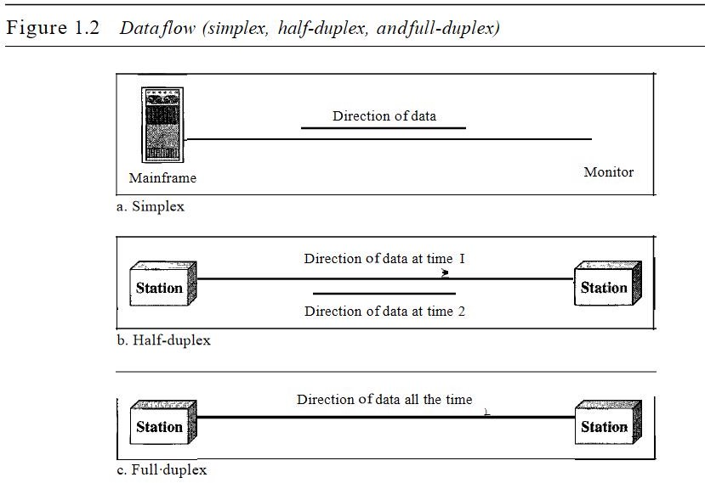

Simplex
In simplex mode, the communication is unidirectional, as on a one-way street. Only one of the two devices on a link can transmit; the other can only receive (see Figure 1.2a).
Keyboards and traditional monitors are examples of simplex devices.
Advantage of Simplex mode:
- In simplex mode, the station can utilize the entire bandwidth of the communication channel, so that more data can be transmitted at a time.
Disadvantage of Simplex mode:
      - Communication is unidirectional, so it has no inter-communication between devices.

Half-Duplex
In half-duplex mode, each station can both transmit and receive, but not at the same time. When one device is sending, the other can only receive, and vice versa (see Figure 1.2b) Walkie- talkies and CB (citizens band) radios are both half-duplex systems. The half-duplex mode is used in cases where there is no need for communication in both directions at the same time.
Advantage of Half-duplex mode:

      - In half-duplex mode, both the devices can send and receive the data and also can utilize the entire bandwidth of the communication channel during the transmission of data.

Disadvantage of Half-Duplex mode:
      - In half-duplex mode, when one device is sending the data, then another has towait, this causes the delay in sending the data at the right time.

Full-Duplex
In full-duplex mode (also called duplex), both stations can transmit and receive simultaneously (see Figure 1.2c).The full-duplex mode is like a two-way street with traffic flowing in both directions at the same time. One common example of full-duplex communication is the telephone network. When two people are communicating by a telephone line, both can talk and listen at the same time. The full-duplex mode is used when communication in both directions is required all the time.
Advantage of Full-duplex mode:
      - Both the stations can send and receive the data at the same time.

Disadvantage of Full-duplex mode:
      - If there is no dedicated path exists between the devices, then the capacity of the communication channel is divided into two parts.

2.3.3 Data link layer Frame

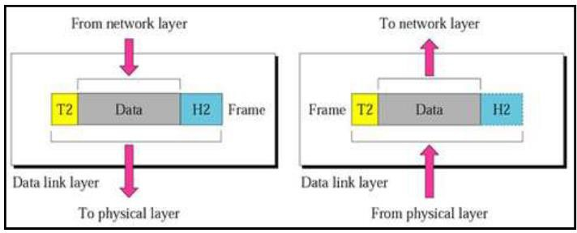

2.4 Ethernet Switching

2.4.1 Ethernet Framing

Ethernet Encapsulation
This module starts with a discussion of Ethernet technology including an explanation of MAC sublayer and the Ethernet frame fields.
Ethernet is one of two LAN technologies used today, with the other being wireless LANs (WLANs). Ethernet uses wired communications, including twisted pair, fiber-optic links, and coaxial cables.
Ethernet operates in the data link layer and the physical layer. It is a family of networking technologies defined in the IEEE 802.2 and 802.3 standards. Ethernet supports data bandwidths of the following:
- 10 Mbps
- 100 Mbps
- 1000 Mbps (1 Gbps)
- 10,000 Mbps (10 Gbps)
- 40,000 Mbps (40 Gbps)
- 100,000 Mbps (100 Gbps)
Data Link Sublayers
IEEE 802 LAN/MAN protocols, including Ethernet, use the following two separate sublayers of the data link layer to operate. They are the Logical Link Control (LLC) and the Media Access Control (MAC), as shown in the figure.
Recall that LLC and MAC have the following roles in the data link layer:
- LLC Sublayer - This IEEE 802.2 sublayer communicates between the networking software at the upper layers and the device hardware at the lower layers. It places information in the frame that identifies which network layer protocol is being used for the frame. This information allows multiple Layer 3 protocols, such as IPv4 and IPv6, to use the same network interface and media.
- MAC Sublayer - This sublayer (IEEE 802.3, 802.11, or 802.15 for example) is implemented in hardware and is responsible for data encapsulation and media access control. It provides data link layer addressing and is integrated with various physical layer technologies.
This shows the OSI network, data link, and physical layers. It also shows the data link layer LLC and MAC sublayers and various LAN/WAN protocols. At the top of the diagram is the network layer and the network layer protocol. Below that is the data link layer and its sublayers. The top sublayer is the LLC sublayer as specified in IEEE 802.2. Next is the MAC sublayer with three columns representing different types of network technologies. The first column is Ethernet IEEE 802.3 at the upper part of the MAC sublayer. Below this are various Ethernet standards for Fast Ethernet, Gigabit Ethernet, etc. that span across the lower part of the MAC sublayer and the entire OSI physical layer. The next column is WLAN IEEE 802.11 at the upper part of the MAC sublayer. Below this are the various WLAN standards for different types of wireless communications that span across the lower part of the MAC sublayer and the entire OSI physical layer. The last column is WPAN IEEE 802.15 at the upper part of the MAC sublayer. Below this are various WPAN standards for Bluetooth, RFID, etc. that span across the lower part of the MAC sublayer and the entire OSI physical layer.

MAC Sublayer
The MAC sublayer is responsible for data encapsulation and accessing the media.
Data Encapsulation
IEEE 802.3 data encapsulation includes the following:
- Ethernet frame - This is the internal structure of the Ethernet frame.
- Ethernet Addressing - The Ethernet frame includes both a source and destination MAC address to deliver the Ethernet frame from Ethernet NIC to Ethernet NIC on the same LAN.
- Ethernet Error detection - The Ethernet frame includes a frame check sequence (FCS) trailer used for error detection.
- Ethernet Frame Fields
- The minimum Ethernet frame size is 64 bytes and the expected maximum is 1518 bytes. This includes all bytes from the destination MAC address field through the frame check sequence (FCS) field. The preamble field is not included when describing the size of the frame.
- Note: The frame size may be larger if additional requirements are included, such as VLAN tagging. VLAN tagging is beyond the scope of this course.
- Any frame less than 64 bytes in length is considered a “collision fragment” or “runt frame” and is automatically discarded by receiving stations. Frames with more than 1500 bytes of data are considered “jumbo” or “baby giant frames”.
- If the size of a transmitted frame is less than the minimum, or greater than the maximum, the receiving device drops the frame. Dropped frames are likely to be the result of collisions or other unwanted signals. They are considered invalid. Jumbo frames are usually supported by most Fast Ethernet and Gigabit Ethernet switches and NICs.
2.4.2 Ethernet MAC Address

MAC Address and Hexadecimal
In networking, IPv4 addresses are represented using the decimal base ten number system and the binary base 2 number system. IPv6 addresses and Ethernet addresses are represented using the hexadecimal base sixteen number system. To understand hexadecimal, you must first be very familiar with binary and decimal.
The hexadecimal numbering system uses the numbers 0 to 9 and the letters A to F.
An Ethernet MAC address consists of a 48-bit binary value. Hexadecimal is used to identify an Ethernet address because a single hexadecimal digit represents four binary bits. Therefore, a 48-bit Ethernet MAC address can be expressed using only 12 hexadecimal values.
The figure compares the equivalent decimal and hexadecimal values for binary 0000 to 1111.

Decimal and Binary Equivalents of 0 to F Hexadecimal
The figure is three columns showing the decimal and hexadecimal equivalents of select 4-bit binary numbers. From left to right, the column headings are: decimal, binary, and hexadecimal. Each column has 16 rows below the header.
015345678910111213142100001111001101000101011001111000100110101011110011011110001000010F3456789ABCDE21
Decimal
Binary
Hexadecimal

Given that 8 bits (one byte) is a common binary grouping, binary 00000000 to 11111111 can be represented in hexadecimal as the range 00 to FF, as shown in the next figure.

Selected Decimal, Binary, and Hexadecimal Equivalents
The figure is three columns showing the decimal and hexadecimal equivalents of select 8-bit binary numbers. From left to right, the column headings are: decimal, binary, and hexadecimal. Each column has 18 rows below the header.
02553571015321281922022402181664640000 00001111 11110000 00110000 01010000 01110000 10100000 11110010 00001000 00001100 00001100 10101111 00000000 00100000 00010000 10000001 00000100 00000000 01100000 010000FF0305070A0F2080C0CAF002010810400604
Decimal
Binary
Hexadecimal

When using hexadecimal, leading zeroes are always displayed to complete the 8-bit representation. For example, in the table, the binary value 0000 1010 is shown in hexadecimal as 0A.
Hexadecimal numbers are often represented by the value preceded by 0x (e.g., 0x73) to distinguish between decimal and hexadecimal values in documentation.
Hexadecimal may also be represented by a subscript 16, or the hex number followed by an H (e.g., 73H).
You may have to convert between decimal and hexadecimal values. If such conversions are required, convert the decimal or hexadecimal value to binary, and then to convert the binary value to either decimal or hexadecimal as appropriate.
Ethernet MAC Address
In an Ethernet LAN, every network device is connected to the same, shared media. The MAC address is used to identify the physical source and destination devices (NICs) on the local network segment. MAC addressing provides a method for device identification at the data link layer of the OSI model.
An Ethernet MAC address is a 48-bit address expressed using 12 hexadecimal digits, as shown in the figure. Because a byte equals 8 bits, we can also say that a MAC address is 6 bytes in length.
The diagram shows that MAC address are composed of 48 bits total. These 48 bits can be divided into twelve 4-bit groupings, or 12 hex digits. Combining two hex digits together makes a byte, therefore the 48 bits is also equivalent to 6 bytes.
1111 1111 1111 1111 1111 1111 1111 1111 1111 1111 1111 1111

All MAC addresses must be unique to the Ethernet device or Ethernet interface. To ensure this, all vendors that sell Ethernet devices must register with the IEEE to obtain a unique 6 hexadecimal (i.e., 24-bit or 3-byte) code called the organizationally unique identifier (OUI).
When a vendor assigns a MAC address to a device or Ethernet interface, the vendor must do as follows:
- Use its assigned OUI as the first 6 hexadecimal digits.
- Assign a unique value in the last 6 hexadecimal digits.
Therefore, an Ethernet MAC address consists of a 6 hexadecimal vendor OUI code followed by a 6 hexadecimal vendor-assigned value, as shown in the figure.
the first six hex digits of a MAC address (AKA first 6 hex digits or first 3 bytes) is the organizational unique identifier and the last six hex digits is vendor assigned
111111111111111111111111111111111111111111111111
For example, assume that Cisco needs to assign a unique MAC address to a new device. The IEEE has assigned Cisco a OUI of 00-60-2F. Cisco would then configure the device with a unique vendor code such as 3A-07-BC. Therefore, the Ethernet MAC address of that device would be 00-60-2F-3A-07-BC.
It is the responsibility of the vendor to ensure that none of its devices be assigned the same MAC address. However, it is possible for duplicate MAC addresses to exist because of mistakes made during manufacturing, mistakes made in some virtual machine implementation methods, or modifications made using one of several software tools. In any case, it will be necessary to modify the MAC address with a new NIC or make modifications via software.
Frame Processing
Sometimes the MAC address is referred to as a burned-in address (BIA) because the address is hard coded into read-only memory (ROM) on the NIC. This means that the address is encoded into the ROM chip permanently.
Note: On modern PC operating systems and NICs, it is possible to change the MAC address in software. This is useful when attempting to gain access to a network that filters based on BIA. Consequently, filtering or controlling traffic based on the MAC address is no longer as secure.
When the computer boots up, the NIC copies its MAC address from ROM into RAM. When a device is forwarding a message to an Ethernet network, the Ethernet header includes these:
- Source MAC address - This is the MAC address of the source device NIC.
- Destination MAC address - This is the MAC address of the destination device NIC.
2.4.3 Ethernet MAC Address

Switch Fundamentals
Now that you know all about Ethernet MAC addresses, it is time to talk about how a switch uses these addresses to forward (or discard) frames to other devices on a network. If a switch just forwarded every frame it received out all ports, your network would be so congested that it would probably come to a complete halt.
A Layer 2 Ethernet switch uses Layer 2 MAC addresses to make forwarding decisions. It is completely unaware of the data (protocol) being carried in the data portion of the frame, such as an IPv4 packet, an ARP message, or an IPv6 ND packet. The switch makes its forwarding decisions based solely on the Layer 2 Ethernet MAC addresses.
An Ethernet switch examines its MAC address table to make a forwarding decision for each frame, unlike legacy Ethernet hubs that repeat bits out all ports except the incoming port. In the figure, the four-port switch was just powered on. The table shows the MAC Address Table which has not yet learned the MAC addresses for the four attached PCs.
Note: MAC addresses are shortened throughout this topic for demonstration purposes.
The diagram shows four hosts, along with their associated MAC addresses, connected to ports 1 - 4 on a switch. The MAC address table which maps ports to MAC addresses is currently empty.
ABCD1234

Note: The MAC address table is sometimes referred to as a content addressable memory (CAM) table. While the term CAM table is fairly common, for the purposes of this course, we will refer to it as a MAC address table.
2.4.4 Switch Speeds and Forwarding

Frame Forwarding Methods on Cisco Switches
As you learned in the previous topic, switches use their MAC address tables to determine which port to use to forward frames. With Cisco switches, there are actually two frame forwarding methods and there are good reasons to use one instead of the other, depending on the situation.
Switches use one of the following forwarding methods for switching data between network ports:
- Store-and-forward switching - This frame forwarding method receives the entire frame and computes the CRC. CRC uses a mathematical formula, based on the number of bits (1s) in the frame, to determine whether the received frame has an error. If the CRC is valid, the switch looks up the destination address, which determines the outgoing interface. Then the frame is forwarded out of the correct port.
- Cut-through switching - This frame forwarding method forwards the frame before it is entirely received. At a minimum, the destination address of the frame must be read before the frame can be forwarded.
A big advantage of store-and-forward switching is that it determines if a frame has errors before propagating the frame. When an error is detected in a frame, the switch discards the frame. Discarding frames with errors reduces the amount of bandwidth consumed by corrupt data. Store-and-forward switching is required for quality of service (QoS) analysis on converged networks where frame classification for traffic prioritization is necessary. For example, voice over IP (VoIP) data streams need to have priority over web-browsing traffic.
Cut-Through Switching
In cut-through switching, the switch acts upon the data as soon as it is received, even if the transmission is not complete. The switch buffers just enough of the frame to read the destination MAC address so that it can determine to which port it should forward out the data. The destination MAC address is located in the first 6 bytes of the frame following the preamble. The switch looks up the destination MAC address in its switching table, determines the outgoing interface port, and forwards the frame onto its destination through the designated switch port. The switch does not perform any error checking on the frame.
Memory Buffering on Switches
An Ethernet switch may use a buffering technique to store frames before forwarding them. Buffering may also be used when the destination port is busy because of congestion. The switch stores the frame until it can be transmitted.
Duplex and Speed Settings
Two of the most basic settings on a switch are the bandwidth (sometimes referred to as “speed”) and duplex settings for each individual switch port. It is critical that the duplex and bandwidth settings match between the switch port and the connected devices, such as a computer or another switch.
There are two types of duplex settings used for communications on an Ethernet network:
- Full-duplex - Both ends of the connection can send and receive simultaneously.
- Half-duplex - Only one end of the connection can send at a time.
Autonegotiation is an optional function found on most Ethernet switches and NICs. It enables two devices to automatically negotiate the best speed and duplex capabilities. Full-duplex is chosen if both devices have the capability along with their highest common bandwidth.
Connections between devices once required the use of either a crossover or straight-through cable. The type of cable required depended on the type of interconnecting devices.
For example, the figure identifies the correct cable type required to interconnect switch-to-switch, switch-to-router, switch-to-host, or router-to-host devices. A crossover cable is used when connecting like devices, and a straight-through cable is used for connecting unlike devices
Most switch devices now support the automatic medium-dependent interface crossover (auto-MDIX) feature. When enabled, the switch automatically detects the type of cable attached to the port and configures the interfaces accordingly. Therefore, you can use either a crossover or a straight-through cable for connections to a copper 10/100/1000 port on the switch, regardless of the type of device on the other end of the connection.
The auto-MDIX feature is enabled by default on switches running Cisco IOS Release 12.2(18)SE or later. However, the feature could be disabled. For this reason, you should always use the correct cable type and not rely on the auto-MDIX feature. Auto-MDIX can be re-enabled using the mdix auto interface configuration command.

